Pre-production: Character Design & Development
前期製作：角色設計與開發

“The Colossus : Alice Victoria Hayward”
「巨神：愛麗斯‧維多利亞‧海沃德」

Course Code & Name | SM4602 - Pre-Production and Prototype (Phase I)  (15-16, Semester A)
Group Assignment | Creative Research on Character Design & Development
Team Name  團隊名稱 | The Father | 父
Team Leader & Member #1隊長 (隊員 #1) | Wong woon him | 黃媛謙
Team Leader & Member #1隊長 (隊員 #1) | 53074912 | LINDY.CITYU@GMAIL.COM
Team Member #2  隊員 #2 | YIP WING SAU | 葉泳秀
Team Member #2  隊員 #2 | 53077999 | WINYIP2@GMAIL.COM
Story Writer:  故事作家 | WONG WOON HIM  &  YIP WING SAU | 黃媛謙  &  葉泳秀
Character Design Artist:  角色設計師 | WONG WOON HIM  &  YIP WING SAU | 黃媛謙  &  葉泳秀
Concept Art Artist:  概念設計藝術家 | WONG WOON HIM  &  YIP WING SAU | 黃媛謙  &  葉泳秀
Animation Director:  動畫導演 | WONG WOON HIM  &  YIP WING SAU | 黃媛謙  &  葉泳秀
Producer & Contact Person:  製片及聯繫人 | WONG WOON HIM  &  YIP WING SAU | 黃媛謙  &  葉泳秀
Contact Information:  聯繫人資料 | Mobile No : 62277049 | Email : LINDY.CITYU@GMAIL.COM
Version &  Date of Creation:  版本及創作日期 | Version : 1 | September 18, 2015

Instruction
Please try your best to complete ALL mandatory sections in detail as follows: (1 - 14)
When complete, use File > Save As... then select Save As Type = PDF as the file format for submission.
Group Leader is responsible to submit this assignment to ACS on or before the deadline.

請盡你所能去用英語詳細填寫以下所有之章節內容 (1 - 14)
完成後，使用 文件>另存為...，然後選擇 保存類型= PDF作為提交的文件格式。
隊長負責在截止日期前提交給ACS。

Mandatory Sections 必須填寫之章節 :
Written Development (1 ~ 9)
- Production Title in both Chinese and English 中英文製作標題
- Concept 創作概念
- Visual Theme 視覺主題
- 故事簡介Synopsis
- Lead Character Basic Settings主角之基本設定
- Lead Character’s Four Essentials Qualities主角的四個必備素質
- Interior Life (Off-Screen; Forms Character; Character Biography)
主角的内在生活及背景故事（在屏幕以外，觀眾看不到的）
- Exterior Life (On-Screen; Reveals Character)
主角的外觀生活及前景故事（在屏幕上觀眾可以看到的）
- Lead Character’s Curriculum Vitae Questionnaire主角的履歷調查表

Visual Development (10 ~ 12)
- Rough Out of Initial Character Design : Including Thumbnail Sketches and Silhouette
主角的初步粗略設計圖：包括縮圖素描及剪影
- Concept Art Design of Lead Character主角的概念藝術設計
- Character Sheet of Lead Character – Final Design詳細主角設計圖解 - 最終設計
- Responsibility Assignment Matrix (RACI Matrix)
責任分配矩陣（RACI矩陣）
- Production Schedule/Timetable 製作計劃時間表

Note: Please notice the gray texts are tips and examples to aid you to conduct your creative research and complete this template. Please delete and replace them with your own words in black color.
Please do not include them in your submission.
Sections in green color is for putting visual elements like image, photo and drawing.

請注意: 灰色的文字祗是提示及示例，用意是幫助你的創作，研究及完成此模板。
請刪除它們然後換上你的寫作及材料(請使用黑色文本)。請不要將它們包含在您的提交內。
綠色的部分是用作放置圖像，照片或圖畫等之視覺元素。

Written Development (1 ~ 9)

1. Production Title in both Chinese and English 中英文製作標題
The Colossus

2. Concept 創作理念
The world setting, gameplay and the main character design are inspired by a 2D computer game named ‘Everending nightmares’ and a 3D computer game called Alice: The madness return. Our storyline is inspired a poem ‘The Colossus’ by Sylvia Plath. In this poem, author tried to re-establish her ‘spiritual supper’ (her dead father). She mentioned about emotions and feelings of the hatred and love dependence of her father.

3. Visual Theme視覺主題
Keywords  關鍵詞名單 | Dark, Victoria London, Mystery, England, 19th Century, murder, horror, violence, dissociative identity disorder, amnesia, electra complex
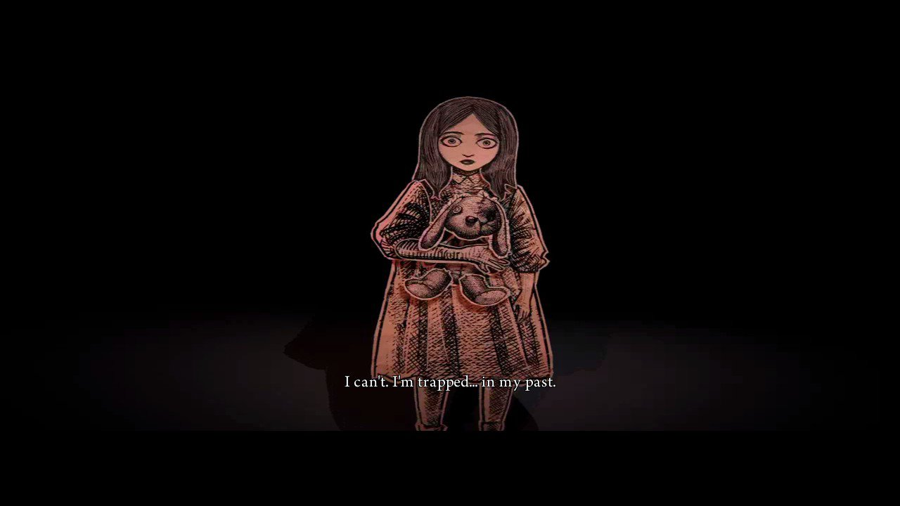  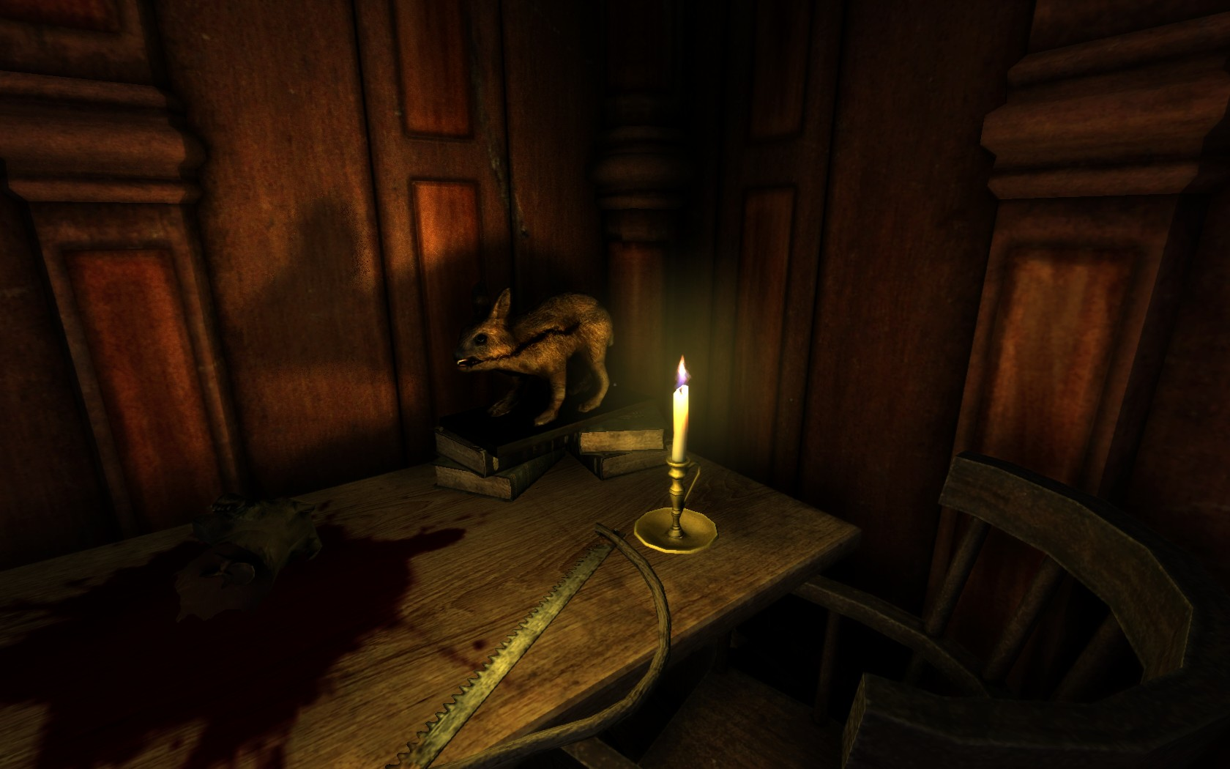  Visual References視覺參考圖像 | 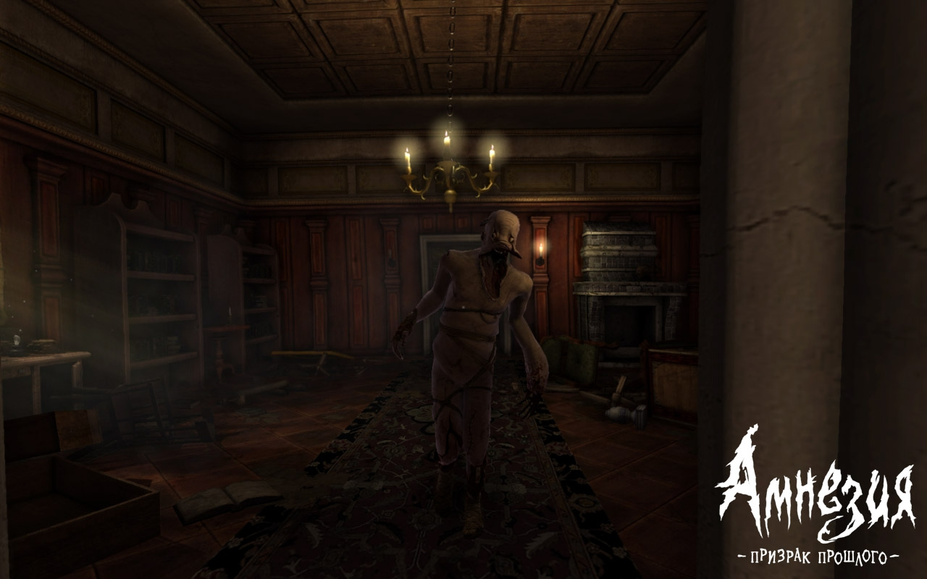  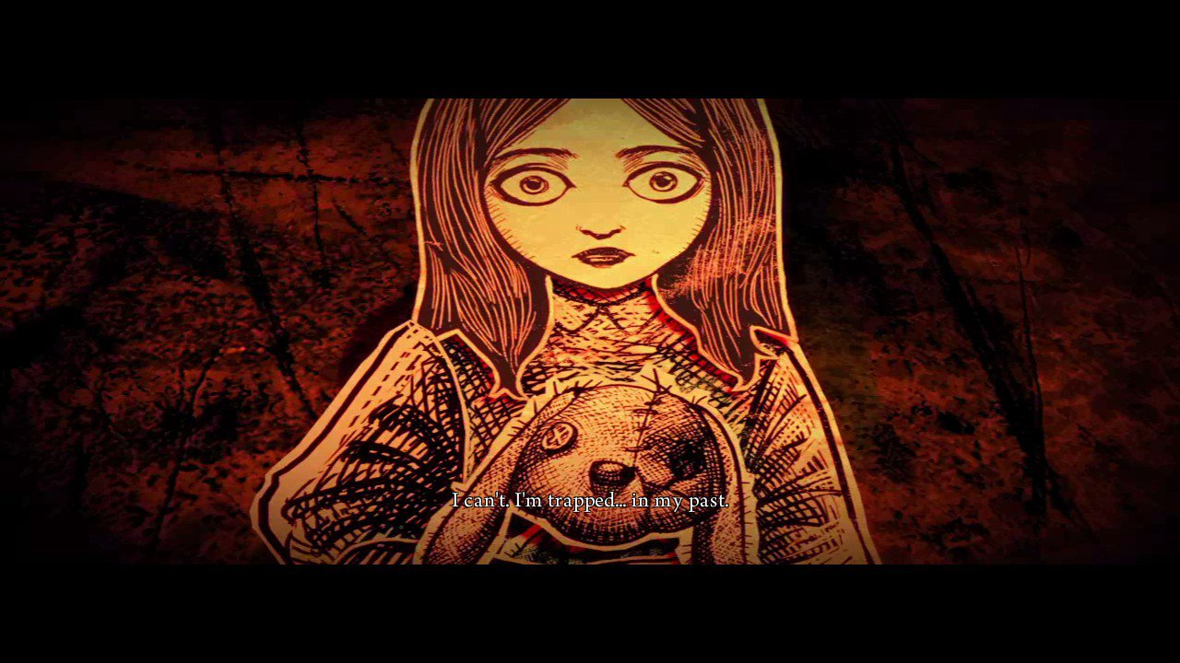  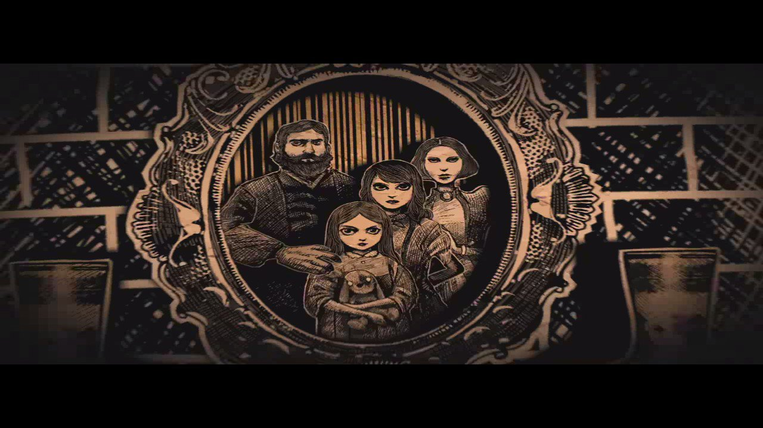  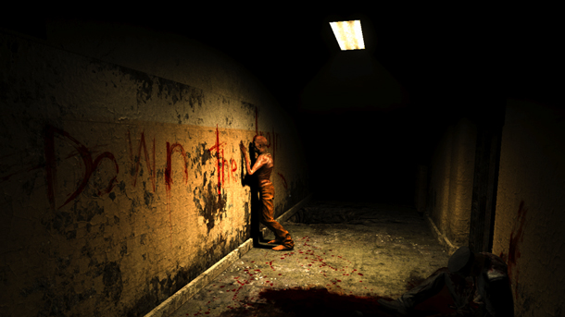  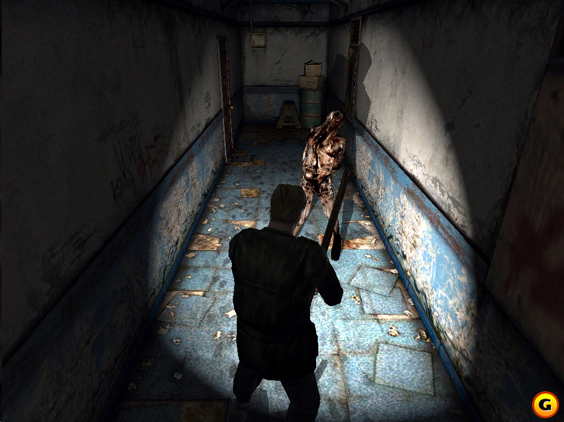

4. Synopsis 故事簡介
One day, Alice has been woken up by the thunder. She was so scary and she went to find her brother. However, Alice found that her father and brother were missing and only Alice was left in the house alone. She started to walk around the house and find out what happened. Some of the room was locked and some of the road was being blocked. She found that something was going wrong but she was trapped in the underworld.

5. Lead Character Basic Settings 主角之基本設定
Role  角色 | Characters and Characterization  人物與表徵 | Settings  (Story World)  故事世界的設定 | Motivation  (Dramatic Need)  動機與戲劇性需要 | Obstacles  障礙及阻力
Lead Character  (Protagonist) 主角 | Black long hair, big green eyes, slim,  13 years-old | 19th century Victoria London, a small traditional rich family | Trying to find her missing father and brother | Bad memories,  Different puzzle tasks,  Trapped at the house

6. Lead Character’s Four Essentials Qualities主角的四個必備素質
I | Strong and Defined Dramatic Need具有強烈以及明確的戲劇性需要
I | He need to finds out what happen with her missing father and brother and hide the sad memories
II | Have Individual Point of View對生活的角度具有個人的觀點
II | Dark, hopeless, never-ending nightmare, sadness
III | Personify an Attitude 對價值體系 (三觀：世界觀、人生觀、價值觀) 的判斷賦予人格化的態度及氣度
III | Family is his first priority. His father and sister are very important. He is very guilty about what he has done (killed his father accidentally). He tried to make her sister feel better and forget the tragedy.
IV | Go through some kind of Change / Transformation其價值體系的判斷會通過某種更改或轉型
IV | At first, the most important thing in his life is family. He thought everything he has done for the family is good for their own sake. But after the tragedy happened, he thought he is the destroyer of the family and not deserved to be a good brother and son.

7. Interior Life (Off-Screen; Forms Character; Character Biography)
主角的内在生活及背景故事（在屏幕以外，觀眾看不到的）
Alice suffered her father’s domestic violence. On the other side, Alice takes her father as her role model.
Main character suffered from dissociative identity disorder and amnesia after his father and sister died. He thought he is Alice, his little sister. After that day, he trapped in his imaginal underworld.

8. Exterior Life (On-Screen; Reveals Character) 主角的外觀生活及前景故事（在屏幕上觀眾可以看到的）
I | Define the need (Action is Character) 主角所需要做的事
I | Solve the puzzles tasks and finds out what happen with her missing father and brother.
II | Professional Life (Work) 主角的專業生活（工作）
II | N/A
III | Personal Life (Marital of social) 主角在社群中的生活（人際關係）
III | Close Relationship with family members, not much friend at all
IV | Private Life (Alone) 主角的私人生活（單獨的時候）
IV | Reading story books, playing with dolls, writing poems

9. Lead Character’s Curriculum Vitae Questionnaire (Please try your best to complete all sections) 主角的履歷調查表
1 | Full Birth Name | Alice Victoria Hayward
2 | Birthplace/date | London,  23 June,1873
3 | Relationship w/ Mother | Good and close
4 | Relationship w/ Father | Good and close  (After mother died, she is extremely depended on her father)  She treated his father as her role model
* | Relationship w/ Brother | Good and close  Best friend and buddy  Always stick together
5 | First Memory/Flash Back | Happy family , no worries about money or food
6 | Favorite Food | Cakes, especially lemon tart
7 | Talents | Puzzle game, good at reading story book, writing poems
8 | Flaws | Sport, Poor communication skill
9 | Perceived Purpose in Life | Maintain a good and close family relationship,  Become a nice parent like her father in the future
10 | Astrological Sign (星座) | Cancer
11 | Emotional Makeup | Eyes with dark circle, seldom similes
12 | Superhero Qualities (If appropriate) | N/A
13 | What Does It Love Most? | Family
14 | What Was The Best Moment of Life Thus Far? | The happy memories with family before her mother died
15 | Worst Fear | Dark, Alone, Thunder
16 | Biggest Enemy | Dark side of the family
17 | Love Interest | Reading story books
18 | Best Friend | Brother
19 | Favorite Hobby | Reading story books
20 | Spiritual Orientation | Family Spirit
21 | Political Orientation | N/A
22 | Key Turning Point(s) in Character’s Life | - After mother died  - Father’s Domestic violence  - After father was killed by brother
23 | Natural Defenses (天然防禦能力) | N/A
24 | Attitude Towards Work | Negative, but will take active
25 | Education/Training | Primary school, Junior Secondary school
26 | Occupation | Student
27 | Occupation Of Parents | Businessman, Gun Collector
28 | Social Status | Rich family but not many friends, not so famous
29 | Pets | Missing Cat after mother died
30 | Well-Traveled? If yes, where? | No. Only spend her lifetime in London
31 | Sense of Humor | Not much
32 | Favorite Band/Music Genre | Classical music
33 | Favorite Restaurant | Lemon tart baked by mum
34 | Family Backgrounds | High educational level
35 | Most Frightening Memory | Father’s Domestic violence
36 | Main Goals In Life | Maintain a good and close family relationship,  Become a nice parent like her father in the future
37 | Favorite Color | Brown
38 | Favorite Known Designer/Hero | Father
39 | Type of vehicle s/he drive/take | House-ride car
40 | Story World Limits, Possibilities | Only inside the house ( a part of the house which contains 3 rooms)  There is 3 levels in total
41 | Favorite Drink | English Tea
42 | Most Prized Possession (最珍愛的物品) | Pocket Watch which was given by her mother as a Christmas gift
43 | Secret Insecurity (隱藏之不安事) | Father’s Domestic violence
44 | Siblings (兄弟姐妹) | William (Brother, Age 15)

Visual Development (10 ~ 12)

10. Rough Out of Initial Character Design : Including Thumbnail Sketches and Silhouette
主角的初步粗略設計圖：包括縮圖素描及剪影
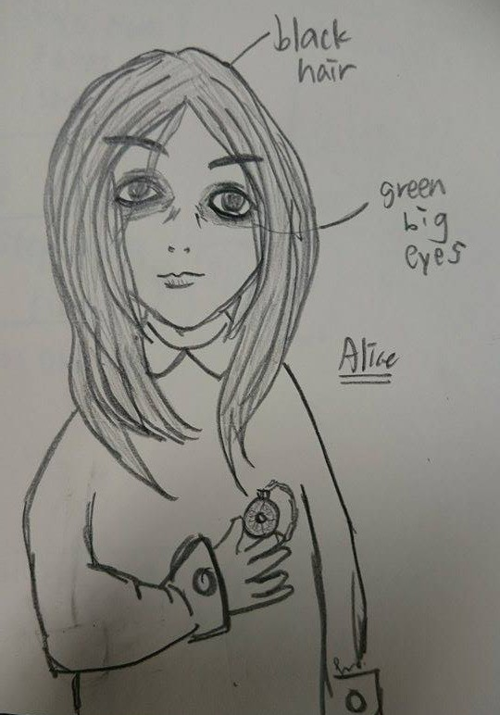

11. Concept Art Design of Lead Character 主角的概念藝術設計
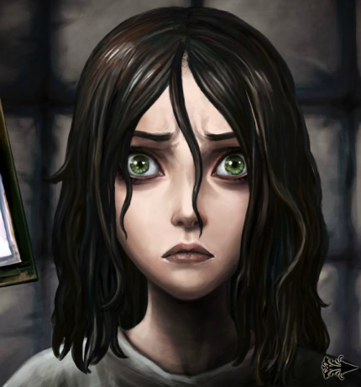


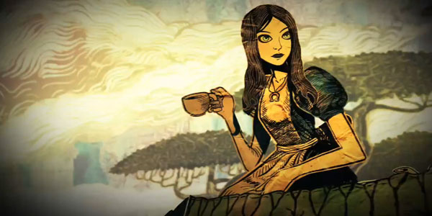
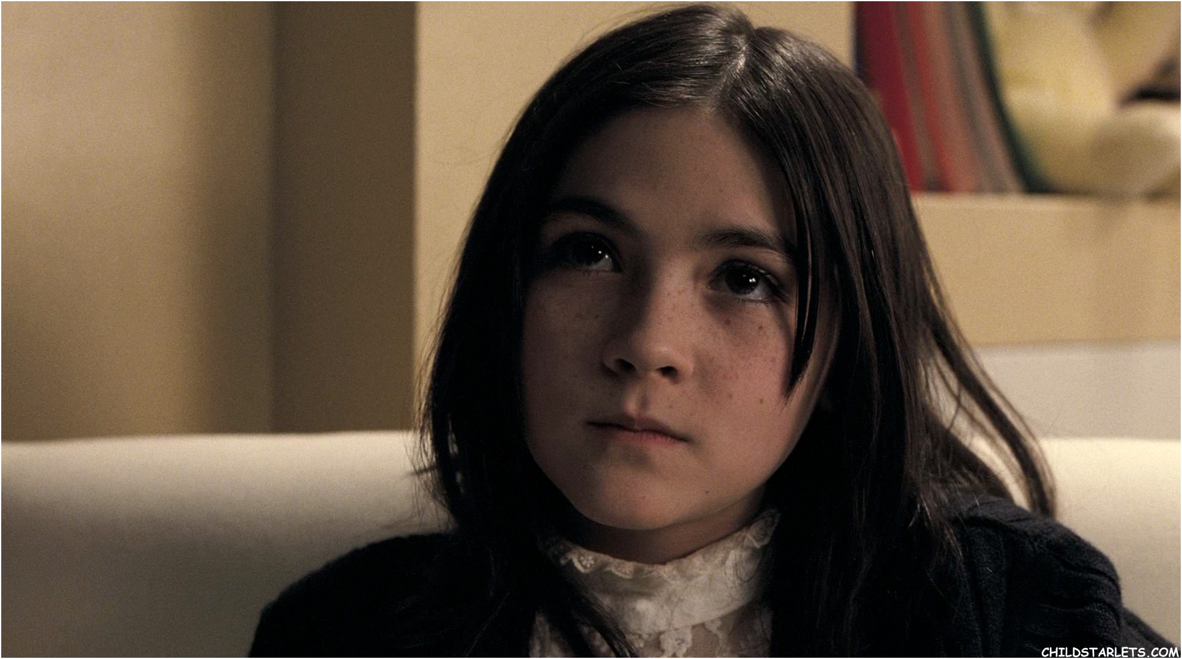

12. Character Sheet of Lead Character – Final Design 詳細主角設計圖解 - 最終設計
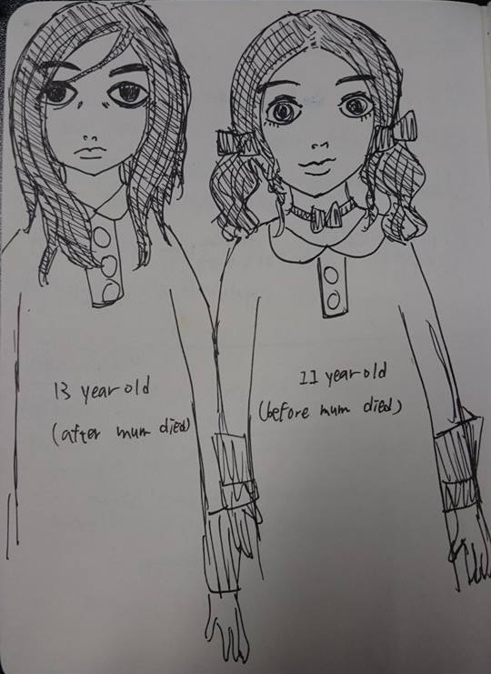

13. Responsibility Assignment Matrix (RACI Matrix) – Estimated Figures責任分配矩陣（RACI矩陣）
 | Concept / Story | Character Design | Scenes settings | Gameplay | Interactive Techniques | Game Programming | 3D Modeling / Texturing | Debugging and Testing
Yip Wing Sau | 50% | 100% | 100% | 50% | 0% | 0% | 100% | 50%
Wong Woon Him | 50% | 0% | 0% | 50% | 100% | 100% | 0% | 50%
Total:
Mainly Programming Part: Wong Woon Him
Mainly Animation Part: Yip Wing Sau

